1. cd: Change the directory to a different location.

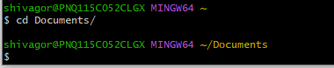

1. ls: List the contents of the current directory.

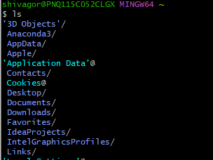

1. mkdir: Create a new directory.

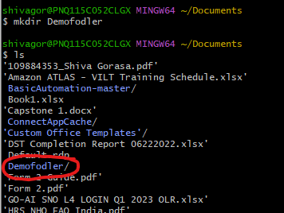

1. touch: Create a new file.

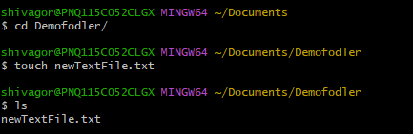

1. rm: Remove a file or directory.

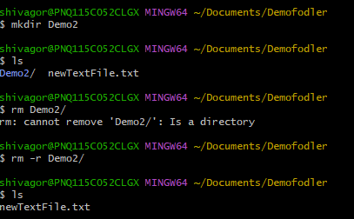

1. cp: Copy a file or directory.

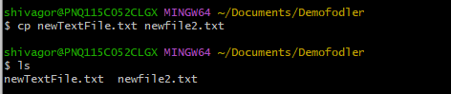

1. mv: Move or rename a file or directory.

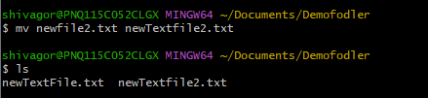

1. echo: Print text to the terminal.



1. cat: Concatenate and print the contents of a file.



1. grep: Search for a pattern in a file.



1. chmod: Change the permissions of a file or directory.
2. sudo: Run a command with administrative privileges.
3. df: Display the amount of disk space available.

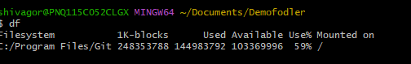

1. history: Show a list of previously executed commands.

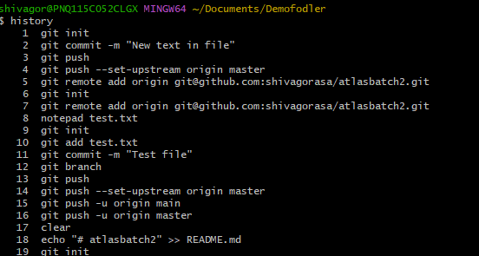

1. ps: Display information about running processes.

